 | SR UNIVERSITY  Campus Warangal
 | Program: II - B. Tech (CS& AI) Batch:
 | Name: BHUPATHI DEEKSHITHA Roll. No:2503A54024
 | Department: Computer Science and AI Semester: I
 | AI Assisted Coding-Assignment Date: 18-09-2026

QUESTION 1 :
Class with Conditional Logic – Employee Salary
Prompt:
Create a Python program using an Employee class with name and basic_salary. Calculate a 10% bonus if salary ≥ ₹50,000, otherwise 5%. Calculate and display the total salary. Create two employee objects and test both conditions.
CODE :
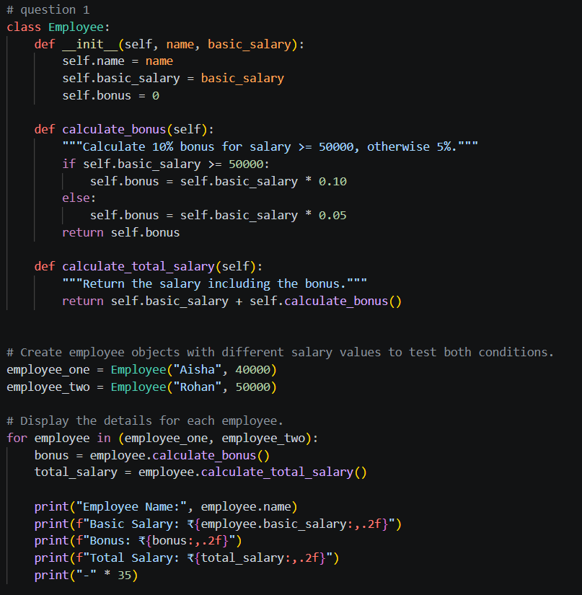
OUTPUT:
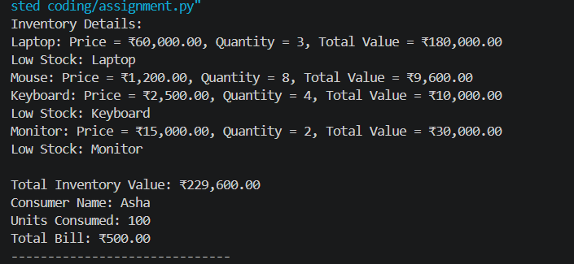

OBSERVATION:
The Employee class successfully calculates a 10% bonus for salaries ≥ ₹50,000 and 5% otherwise.
The program displays the employee name, basic salary, bonus, and total salary correctly.

QUESTION 2 :
A teacher wants to analyze the marks of students using an AI coding assistant.
PROMPT:
Create a complete Python program that accepts a list of student marks and uses
a loop to process each mark. Display "Distinction" for marks ≥ 75, "Pass" for
marks ≥ 40 and < 75, and "Fail" for marks < 40. Ignore invalid marks outside
the range 0–100. Count and display the number of students in each category.
Test the program using a suitable list containing valid and invalid marks.
Use meaningful variable names, conditional statements, and brief comments.
Do not use external libraries.
CODE:
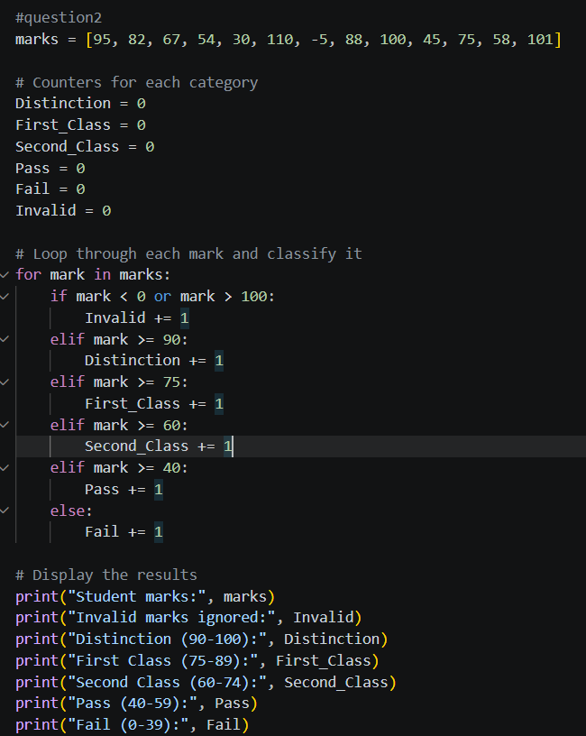
OUTPUT:
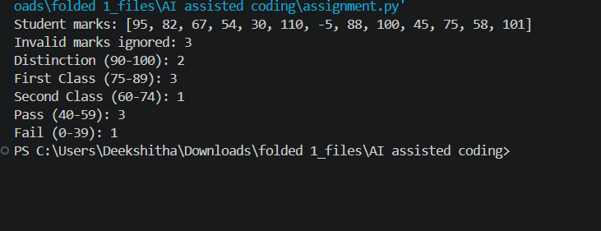
OBSERVATION:
The program uses a loop and conditional statements to classify valid marks into Distinction, Pass, and Fail.
Invalid marks outside 0–100 are ignored, and the number of students in each category is displayed.
QUESTION 3:
A small store wants to maintain product inventory using a Python program generated with AI assistance.
PROMPT :
Create a complete Python program using a Product class with product name, price,
and quantity attributes. Add a total_value() method that calculates price × quantity.
Create a list containing at least three Product objects. Use a loop to calculate
the total inventory value and display each product's details. If a product's
quantity is less than 5, display "Low Stock" for that product. Use meaningful
variable and method names, brief comments, and no external libraries. Make sure
the program runs without errors.
CODE:
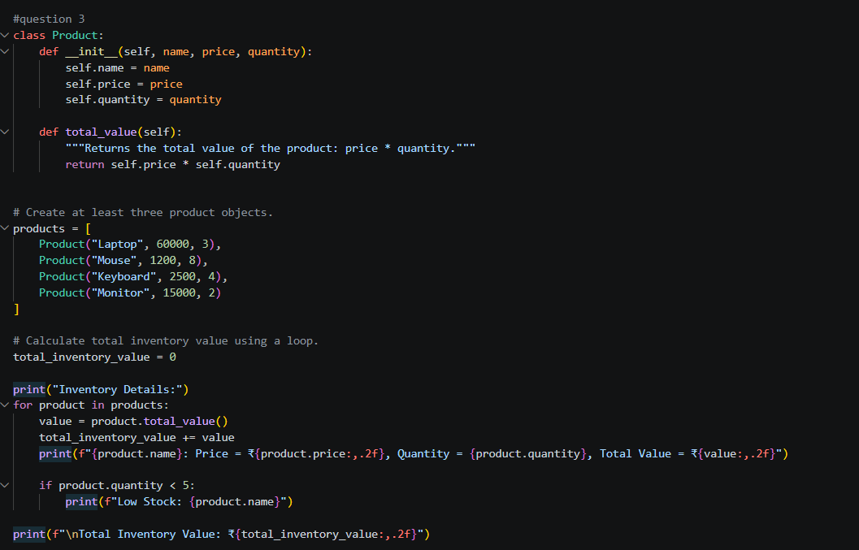
OUTPUT:
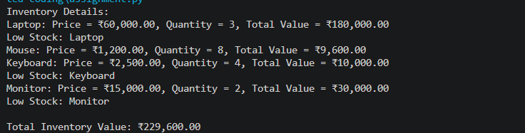
OBSERVATION:
The Product class calculates the total value of each product using price × quantity.
The loop calculates the total inventory value and identifies products with quantity below 5 as Low Stock.

QUESTION 4 :
An electricity board wants to calculate bills based on units consumed.
PROMPT:
Create a complete Python program using an ElectricityBill class with consumer
name and units consumed. Calculate the electricity bill using these rates:
first 100 units at ₹2 per unit, units 101–200 at ₹3 per unit, and units above
200 at ₹5 per unit. Use appropriate conditional statements and loops where
required. Create at least three ElectricityBill objects with different unit
values, including edge values such as 100 and 200. Display consumer name,
units consumed, and total bill. Use meaningful variable and method names,
brief comments, and no external libraries. Ensure the program runs without errors.

CODE:
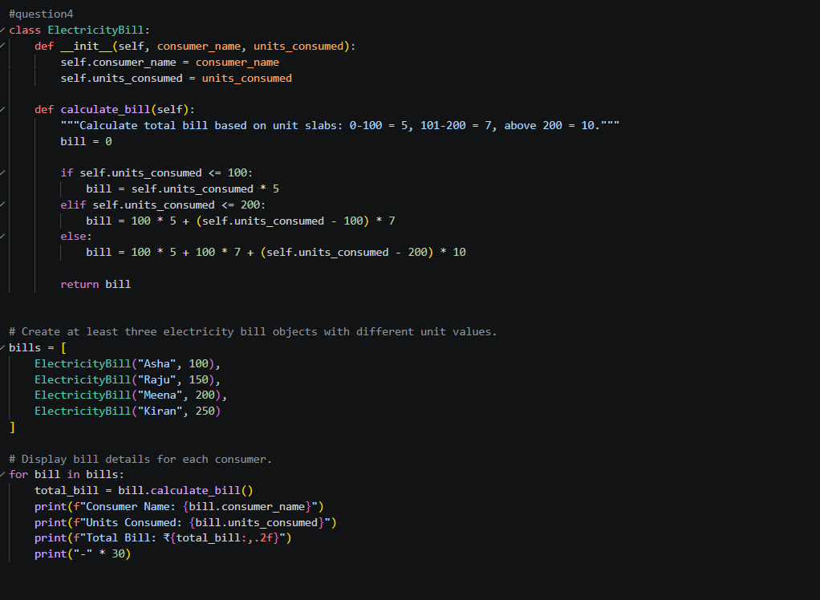
OUTPUT:
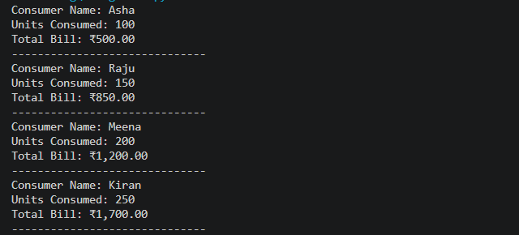

OBSERVATION:
The ElectricityBill class calculates bills according to the specified unit-wise rates using conditional logic. Different unit values, including the edge values 100 and 200, are processed and displayed correctly.

